CYCLES IN NATURE

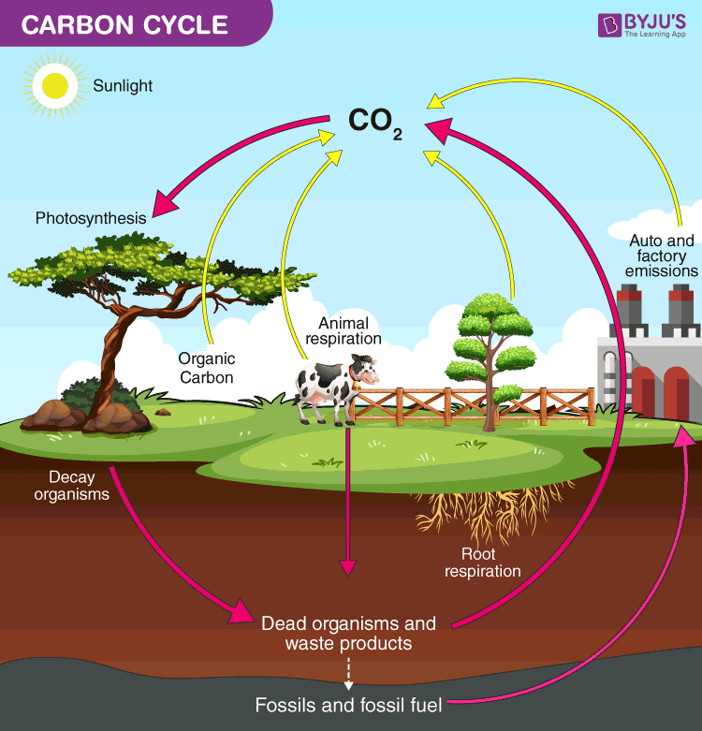
Elements such as carbon, oxygen, hydrogen, nitrogen and sulphur are recycled in nature - this is the role of the decomposers.

Carbon Cycle

The element carbon is one of the main materials in sugars, proteins and fats - these are found in the tissues of all living things. Carbon is also found in vitamins, as well as in waste products such as CO₂ and urea.

In the carbon cycle, plants convert CO₂ to food and O₂ during photosynthesis.

Animals (and plants at night) produce CO₂ during respiration.

On decomposition, all plant and animal material is reduced to CO₂ by the decomposers, and the residual nutrients are returned to the soil.

Nitrogen Cycle

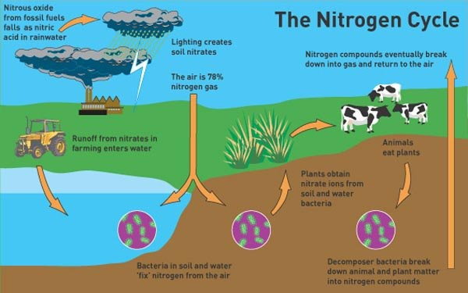
Nitrogen makes up 78% of the atmosphere, is found combined with oxygen as nitrates in the soil, and is one of the elements found in proteins (these are the building blocks of cells and tissues).

Animals obtain their nitrogen either from plants or other animals.

Plants get their nitrogen from the nitrates in the soil. They are soluble in water and are easily absorbed by plant roots.

Nitrates can be formed in the following ways.

• The decay of dead organisms by decomposers.

• Atmospheric nitrogen changed by nitrogen-fixing bacteria in the soil and
in nodules on the roots of legumes such as clover, peas and beans.

• Lightning causes atmospheric nitrogen N₂ to react with O₂ to form oxides
of nitrogen. These form nitrates when they dissolve into water.
Phosphorus Cycle

The phosphorus cycle models how phosphorus moves from the lithosphere to the hydrosphere and then through food chains and back.

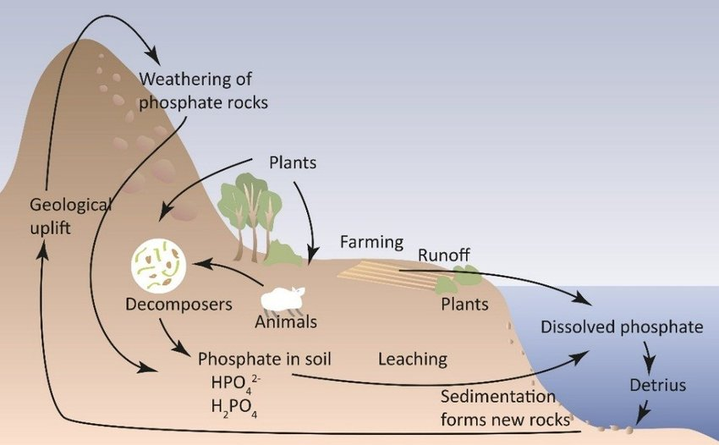

Phosphorus is essential for plant and animal growth, as well as the health of microbes inhabiting the soil, but is gradually depleted from the soil over time. The main biological function of phosphorus is that it is required for the formation of nucleotides, which comprise DNA and RNA molecules. Specifically, the DNA double helix is linked by a phosphate ester bond.

Calcium phosphate is also the primary component of mammalian bones and teeth, insect exoskeletons, phospholipid membranes of cells, and is used in a variety of other biological functions.

The phosphorus cycle is an extremely slow process, as various weather conditions (e.g. rain and erosion) help to wash the phosphorus found in rocks into the soil. In the soil, the organic matter (e.g. plants and fungi) absorb the phosphorus to be used for various biological processes.

